Hacker Homestead
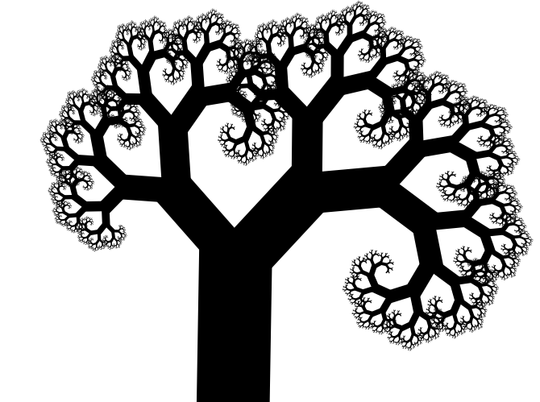

Fertile Framework

The Computer

A Practical, Liberal Arts Education for Hackers
By Andrew Brady

Table of Contents
Preface 4
About This Book 4
About The Series 5
Intended Audience 7
Contents of This Book 7
Conventions 9
Code Examples 9
Feedback 10
Resources 11
Acknowledgments 11
Hacker Homestead 12
Companion Materials 12
Computers 14
The Diligent Worker 15
Father of Modern Computing 18
Input / Output (IO) 21
Memory 22
Central Processing Unit (CPU) 22
Storage 22
Hardware 23
Recommended Computer Hardware 24
Laptops 24
IBM Thinkpad T60 (2006) 25
IBM Thinkpad X60 [Tablet] (2006) 25
Apple MacBook Pro 13 Inch (Mid 20210) 26
Thin Clients 27
Wyse Cx0 (~2010) 28
HP t5710 (2005) 29
Desktop 30
Something else? 30
Firmware 31
Summary 31
BootProcess 31
BIOS 31
UEFI 31
Bootloaders 31
U-Boot 31
GRUB 31
Others 31
Operating System 32
Summary 32
FreeDOS 32
Popular Linux Distributions 32
Alpine Linux 32
Linux From Scratch (LFS) 32
Buildroot with buildroot 32
Programming 33
Assembly Language 33
Boot Sector Program 33
TetrOS 33
Clang 33
C++ 33
Python 34

Preface

About This Book
This book is for those who want a practical guide for the digital universe works. We provide a vertical slice approach to learning modern computers. The Computer will teach important concepts using examples that apply to large and small systems, from Mainframes and the “Cloud” all the way down to embedded devices that we interact with everyday.
I wrote this book for a few reasons
1) To offer an entry point for those who want to look deeper into computers but don’t exactly know where to start. With all the advancements and just volumes of work done to advance the field it could be overwhelming to the new learner seeking to both understand our digital machines from the ground up and instead eyes glaze over and just consume what what is fed by popular culture (Im looking at you fortnight and tiktok).
2) When I was a boy your computer was expected to come with a means to program it out of the box. This “creator culture” was baked right in. Imagine if your iPad forced you to learn a bit about it prior to smashing your fingers onto a video, game, or some other instant dopamine response. Stand back for a second and ask yourself is the computer using you, or you it?
Of course not everyone needs to be a mechanic or an engineer in order to drive a car. But I would suggest when the ratio of mechanics dips under about 1 in 5 we might be at risk of being controlled by someone elses idea of what and how a car should be. Espesselly when its such a critical part of our everyday lives.
3) As a young boy in the 1st grade in 1986 at the dawn of the “desktop revolution” (That is the period when computers becoming affordable really took off). I was diagnosed with Dyslexia, Dysgraphia, and a shortage of working memory these “learning disabilities” that are now covered under the board umbrella of “neodivergint”. School was difficult as this combo of neroprocessing differences where not all that compatable with standard teaching methods at the time. I was lucky enough that between my parents and teachers exploring new methods to help kids like me achieve their potential I had technology thrown at me to help with writing, memory, reading, spelling, math, and early voice dictation. Computers helped me build a model of the world. A simple model that used levels of abstraction and offloaded my own need to route memorization tasks. As I grew this cross applied to understanding and modeling other difficult concepts like social interactions, philiphiy, economics, etc. technology became not only a means of accomidation but a model, a mircocosum for understanding the universe as it related to me.
So with 25+ years of professional experience in the field now, I thought I would take up the touch and try to help others like me discover themselves and the universe around them via this marvel of mankind, the simple machine capable of so much.
The Computer

About The Series
The Fertile Framework series covers a wide range of topics related to technology and computing, from the basics of programming and hardware to advanced concepts in artificial intelligence and machine learning. Each book in the series provides a practical guide for readers who want to learn about modern computing and how it all works from the ground up.
The series is meant to be a snapshot of documentation tools, exersises and commentary that is able to be a self-contained snapshot. Hosestly I have gotten a little annoyed with so much shift towards the cloud. That while very convisnent the default mode for software is to reach out to the internet as a general repository. And well this is really nice when it works but is by no means “self-reliant”. In the Linux and other open sources spaces its not like “they” prupusly hold back the ablity to host and distrubute your own COMPLETE set of software, there are tools and tuturials to become a mirror but this is not the DEFAULT. Instead you can find yourself trying to run something a little orlder for one reason or another and all the defaults assume you are using the most current OS and have a connection to the internet.
What happens if time, censorship, politics … or something as simple as a bankrupsy or lack of intrest orphands a project and breaks the build process requring the uninisated to embark on a dependancy hell that may have no real end. Instead some projects like “Linux From Scratch” or LSF. Address this head on, forcing you to go out and collect the software for your self. Well this sereies is ment to take this one step further in curiating all the collections of software, hardware specs, datasheets, howtos etc. and then providing paths for future learners. Regardless of a post-applolipic future or simply one where the self starter doesn’t have to worry about broken links or expired GPG keys, obsticals that can and should be avoided.
I will generally be covering the last decade plus or minus for a few reasons. One is that the fundimentals and generally software has not radically changed about about the last 15 years. Thats about the time that affordable mulicore 64bit capablie machines hit the market and embeded really took off and some standards emerged. Piror to about 2005 the edge cases where abound and many manufacutures only released binary blobs as drivers, did’t document them and where not supported by the open source community. But as open source software (OSS) really took hold, and most of the manufacurers own engenners wanted to make their hardware work with OSS. We now have a wonderful ecosystem that feels like a human tresure, something that shouldbe free and accessable to all as a fundimental right. This project aims to encaspulate and contrubute to a historical legacy that begain in the 1970s and truly has matured during the post 2005 era.
The Computer – This book introduces the core concepts of modern computing and provides a vertical slice approach to learning about the digital universe.
Networking – This book delves into the world of networking and teaches readers how to set up their own networks. It covers topics such as protocols, routers, switches, firewalls, and security.
Databases – This book explores the world of databases and teaches readers how to design, implement their own database systems. It covers topics such as SQL, relational databases, NoSQL, and “big data”.
Artificial Intelligence – This book introduces readers to the exiting world of artificial intelligence and machine learning. It covers topics such as neural networks, deep learning, natural language processing, computer visions, and more.
The Fertile Framework series is perfect for anyone who wants to learn about modern computing and technology in a practical and fun way. Whether you're a beginner looking to get started with computers or an experienced professional looking to expand your knowledge, these books have something for everyone.

Intended Audience
Beginners, who want to learn about modern computing and how it all works from the ground up. This book is suitable for those who have some experience with computers but are looking for a deep understanding of the underlying principles and concepts. The book is written in an approachable and fun style, making it accessible to readers who may not have a technical background or experience with computers or programming.

Contents of This Book
Chapter 1, Computers, Yep just what it sounds like we are going to introduce the core concepts of the computer. Its basic blueprints can be found in devices large and small. We will introduce the basics of the Von Newman architecture. The blue print for all modern computers from the last 70+ years. While specifics in speed, size, IO (Input/Output) have changed dramatically, an understanding of this basic architecture will give you the necessary grasp on everything from mainframes, gaming consoles, laptops, smart phones, smart TVs, and even industrial controllers used in manufacturing, robotics, and latest generation AI (Artificial Intelligence). It all stems from a common blueprint.
Chapter 2, Hardware, Will introduce you to this editions certified hardware and recommendations on alternatives,
Chapter 3, Virtualization, Wether its in the cloud, a web browser, or on your desktop you will eventually be running on physical hardware. There are good reasons that go all the way back as the 1960s as to why you might virtualize a computer. This chapter will introduce you to the concept, some tools, options, and alternatives to physical “bare metal” hardware for running the examples in this book.
Chapter 4, Operating Systems, for many systems this is the next layer in the stack. The operating system manages the hardware and software resources, abstracting and delegating common services for programs to run, While not all computers require a distinct operating system most do. We will be focusing on Linux or more specifically GNU + Linux as it is not only the most democratized operating system, it is powerful and scales from the smallest IoT (Internet of things) sensors and switches, to large IBM Z Series mainframes. Unix the operating system that Linux models is the basis for Apple iOS & MacOS, Even the proprietary Microsoft Windows witch is POSIX compliant includes many approaches and even exact code that was created adapted from its original open source GNU roots. We will take a practical approach to installing a basic Linux system.
Chapter 5, Programming, With working hardware and operating system we will jump into how you may write instructions for your computer to execute. We will brave though an introduction to the lowest level of human readable code called assembly language. Spend some time on high level programming using the god language C and its super set C++, Lastly we will snake though an interpreted language called Python. We will use some games and other fun examples along the way. Honorable mentions will be BASIC, Lisp, and Smalltalk … and ok Java...darn it, If we are going todo Java I will throw in JavaScript too.
Chapter 6, Synthesis, the combination of ideas to form a theory or system. Bring together your learning in some musing cookbook examples to try. Such as a boot sector virus game, a pixel art program, and a program that simulates life itself.

Conventions
This is the part of the book where we tell you about all the “conventions” like code listing, notes, etc. etc. But I will let you in on a little secret its as much for the writer as it is for you. See as a writer in a word processor, it helps us keep formatting consistent. Providing a single location to go back to and reference special formatting and hopefully just allow us to copy and paste the formatting.
The following typographical conventions are used in the text of this book:
Italic
Indicates emphasis, new terms, URLs, email addresses, filenames, paths and Unit utilities.
Constant-width regular
Indicates commands, variables, attributes, functions, methods, modules, values, the contents of files, the output from commands, and code examples.
Constant-width bold
Indicates commands and other text that should be typed literally by the user, and code examples that demonstrate.
Constant-width Italic
Indicates commands and other text that should be typed literally by the user, and code or command examples.

Code Examples
The following is an example of a code listing. Also this section should talk about the code, scripts and commands and that they may be used or reproduced. They are syntax highlighted where possible and line numbered as appropriate. Just as a side note, if copying and pasting or otherwise reusing the contents of a listing, it should be understood that the line numbers should not be transferred and are for reference only.

1 // Simple C program to display "Hello World"
2
3 // Header file for input output functions
4 #include <stdio.h>
5
6 // main function -
7 // where the execution of program begins
8 int main()
9 {
10
11 // prints hello world
12 printf("Hello World");
13
14 return 0;
15 }

Feedback
Please address comments and questions concerning this book to the publisher & community:
Danger Brady Enterprises
611 North Pine Street
Rolla MO, 64501
To comment or ask technical questions about this book, send email to:
FertileFramework@hackerhomestead.com

Resources
There is a web page for this book that lists errata, examples, and any additional information. You can access this page at:
https://www.hackerhomestead.com/FertileFramework

To Engage with the community at large access our chat server via Discord:
https://discord.gg/nxjvqgFQgJ

For more information about books, projects, resources, and the Hacker Homestead, see:
https://www.hackerhomestead.com

There is a Hacker Homestead Youtube Channel where you may access videos related to this book and other projects at:
https://www.youtube.com/HackerHomestead

Physical Materials such as computers, flash drives, and others mentioned in this book may be purchased on our Ebay Store
https://www.ebay.com/usr/hackerhomestead

If you are a teacher looking to use this book in your classroom there are additional resources available, as well as support for purchasing a classroom set of computers compatible with the material.

Acknowledgments
Thanks for those who have helped put this together

Hacker Homestead
Hacker Homestead is an open source incubator project. We believe that technology should be open, accessible, and empowering.
“We hunt, grow, and share technology to make it possible for everyone to learn, create, and innovate”
We provide resources and support to help open source projects grow and succeed. We engage in education efforts to help demystify computing, closing the gap between hardware and software development.
The Teacup Tinker-board was our first project; an open source development platform. It is a small, affordable, and hackable computer that is perfect for learning about embedded systems and MIPS RISC architecture. It provides a unique, simplified platform for understanding the evolution of computers.
This book series is the second effort to be undertaken and will provide a jumping off point for teaching and promoting sustainable, acessable computing.
Technology History because those who do not learn from history are doomed to repeat it
Technology Literilicy its shown when technology is aviable to a population that the overall quality of life imporves for its citiziens
Anti-Consumumer culture turns out over consuption is a bad thing
Sustainable practices
Preserving Freedom – Technology is for everyone, If we do not understand how a thing works then others will use it to control us
Addressing Privacy in the internet age –

Companion Materials
This book is intended to be a vertical slice of modern computing. While we may not cover everything you need to become a master, we will include attempt to include all software referenced along with critical documentation to explore more on your own. Another reason todo this is for historical and archival reasons. The internet is a vast source of information, but it is also in constant flux links break, companies change hands, people simplicity investing in keeping things where they are. This is generally not an issue thanks for organizations and educational institutions such as the Internet Archive, Massachusetts Institute of Technology, University of California Berkeley and many more. If you are in the future and attempting to locate materials in this book and not having luck reach out to these folks as they likely have a copy. That being said preserving history is really up to all of us. So included with the book are flash or DVD materials with the essentials, and of course also on https://www.hackerhomestead/.
In the appendix you may find a proper index but this is a high level of what is included
- Alpine 3.18.5 Linux Extended Live Image
- Ubuntu 20.04 LTS Desktop Live image
- Linux From Scratch Source Files (LFS)
  - While you will need a bootdisk and some dependency's installed, nice thing is that LFS by default is built from the ground up and dose not rely on a package repo to put together.
- Beyond Linux From Scratch Source Files (BLFS)
  - Same as LFS but more ;)
- Buildroot 2023
  - Buildroot relies on downloading dependencies directly such as kernel source. We will attempt to include major releases of these dependency's and a means to reference them.
- Documentation
  - Intel resources and Datasheets – this is a valueable set of resources the provide a low level understanding of the x86 architecture, Including assembly language specifics
  - BIOS Standards Documentation – For many ages BIOS was king
  - UEFI Standards Documentation – This should include what you might need to understand more about how the UEFI framework works

CHAPTER 1

Computers

CPU
Output
Input
Memory
The above diagram show the most basic components of a modern computer. And by “modern” I do mean since 1946, so you know like 70 years. The concepts in the first digital computer have not really changed. They have gotten smaller, faster, and cheaper. This is mostly thanks to advances in material science around the semi-conductor. The introduction of transistors and then progression of packaging of them into microscopic wafers. But I digress, The pattern even the naming of a computer has remained consistent all this time and so if you wrap your head around the simplified model of a computer it will remain relevant for years to come. The next likely change in computer architecture will be quantum computers and they are still quite far of from being on your desk or carried in everyone's pocket.
In a twist of self reflectional success. All the rapid advancements in computing have been accelerated by computers themselves. That is we have used computers to advance computers and while the curve has slowed it is far from plateauing.
But how? In the following sections follow along as we dive into the how these machines can accomplish so much. But before we dive to deep let me run you though a thought experiment to start building a model from a different perspective … Where you are the computer!

The Diligent Worker
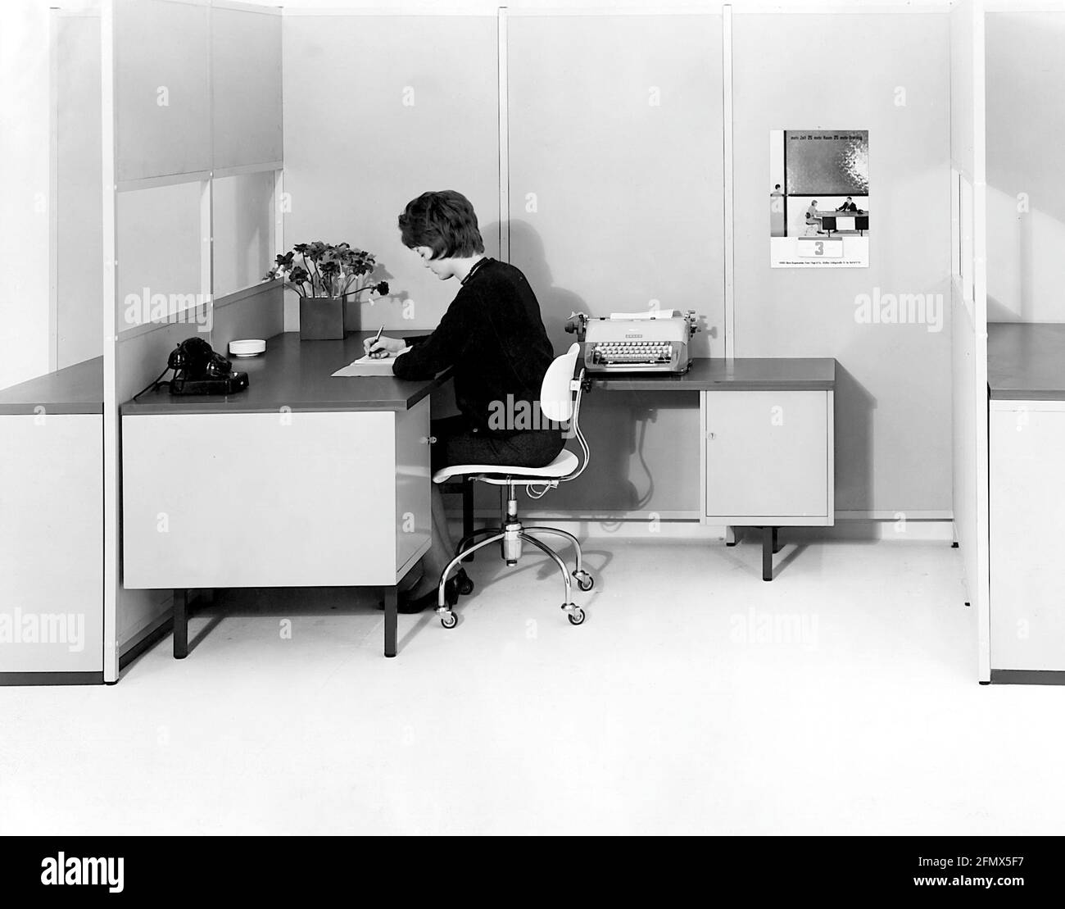
* Not the best picture since it both has more things, and not all the things mentioned
** Plus Telephone and Typewriter comes later (but type writer might be good
You are a diligent worker at Acme Co. When a new customer order comes in you are one in a pool of people in the orders processing department, expected to process paperwork, no computers.
Start by imaging a desk that includes what you need to do your work.
- A clear surface
- In and Out trays
- Tools like pens, pencils, stamps, and typewriter
- Reference cards and lookup tables
- The desk has a few drawers

Lets walk through a typical workflow of someone using this workspace to process a customer order.
- You glance at the clock to keep a consistent pace since after all this is pretty boring work and you know your mind wonders easily.
- Tasks and messages are put into the “In” tray, stacking them on top of each other. Generally they are templated forms filled out by other departments or customers. Memos are also templated with familiar headings like “To”, “From”, and “Subject”, and a blank space for the body of a message. Regardless they are in standardized “formats”
- You take these “inputs” one at a time and place it into the clear space on the desk to start working. In the case of a customer’s order you may have several forms in your inbox that are related, you go through the stack and pull these out so that now you have all three related forms on your desk at once.
- The type of order is specified at the top of the first form. You know what is needed and it’s proper sequence comes next from your your desk reference and lookup tables.
- You proceed to bring out a blank invoice form from your drawer and take information from each form and start filling out a new invoice form. You perform some basic arithmetic to add up things like quantities, pricing, and any calculate any discounts.
- Once finished you stamp the form, sign it and place it in your outbox for someone to pickup and send to the customer.
- Finally before taking the next group of papers you clear your desk either by trashing the now processed forms or you might stamp them for filing and place them in your outbox.
- You then record the order number, date, and customer in a journal as a log.
- You take the next paper from the inbox and start the process all over again, until your inbox is empty.
- When the clock strikes 5:00pm you go home and have a stiff drink.
This “pattern” or “workflow” has been around for a really long time, business and government have been refining the efficacy of clerical work for many hundreds of years. Guess what … the “computer” is not any different. In fact one of the reasons that computers became so popular so quickly for this kind of work is that most humans really would rather not engage is such repetitive work.
The inbox is the “Input Device”
The outbox is the “Output Device”
The clear working desk is the memory unit
The arithmetic/Logic units are like the tools and reference tables on the desk
And then there is of course you. You are the one who ultimately has a way of thinking, taking instructions and executing them. You are the control unit along with your friend the clock of course.
And just like a computer you are reprogrammable, able to adapt to new kinds of instructions whether it be to process an order and next write a memo or fill out an interoffice survey. And over time as new forms are developed you update your programming to adapt, even though basically all that has changed is the content of the data not the tools needed to accomplish the task.
But if we go deeper it gets a little less familiar… because you see the computer only understands a language of binary, on and offs or for simplicity 1s and 0s. Generally these are grouped 8 together to make a byte and 16 together to form a word. (Two bytes is a word) and a single on or off state is called a bit.
Just like us computers use timing and patterns to understand input.
This grouping allows the computer to draw the line on how much information it will process at a time. Kind of like our conventions for reading back a phone number 555-555-5555.

Father of Modern Computing
One of the most important figures in computer science was John von Neumann a mathematician, physicist, engineer and polymath.
All modern computers, including the the ones in your car, tv, phone, game console, digital watch, etc. are based on what is referred to as the “von Neumann architecture”
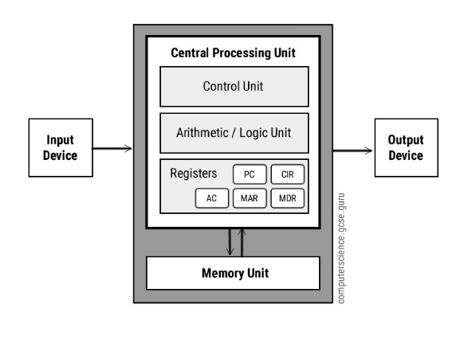
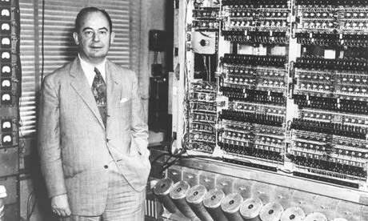
*John von Neumann - ENIAC 1946
* Simplified Computer Model
Lets try to cover the concept of a computer at a high level. I want you to keep this simple model and a few basic rules in your head, or refer back to it as you learn more of the details of specific devices, and test to see if the simple model holds true.
Nothing really interacts with the CPU directly. 1) All Input is fed to memory 2) Memory is read by the CPU (Ether this is an instruction or a value 3) CPU reads from locations in memory 4) CPU Computes a result and writes to memory 5) Output devices read from memory locations and output those values from memory.
THAT IS IT! That is how every Computer, smart TV, digital cell phone, Mainframe, and Game console work. The key to a universal understanding of modern technology is to learn how to manipulate input into memory and get the desired result.
Of course that is a very simplistic model. Just like anything in life you do have to learn how to ask the right questions, say the right words. In this case its learning to en-“code” in such a way that the computer does the maths so you can play a game or predict the weather.
Lets unpack the concept further...

Input / Output (IO)
While Input and Output are their own distinct elements, we often group them together since from a practical perspective they are often paired together. Some obvious examples are keyboard (input) and display (output). Even modern display standards such as HDMI preform a “handshake” meaning that in order for it to function properly the output device must also be ready to receive input. This goes for other standards such as USB too. But at a low level they are really two devices with a combined input and controller.
* Note: Unerversial Serial Bus (USB) is a topic on Praferials and Buses of its own and deservies its own chapiter if not a whole book *
Speaking of an IO “controller” lets explore how one of those might work, such as a USB keyboard that has been connected. See the USB device when it was “loaded” by the computer was read (Input) into a location in memory. This might be handled by a hard coded firmware, a BIOS/UEFI or from the Operating System (We will discuss those later on) but the end result is a range of memory addresses that represent the state and critical information related to the devices plugged in; such as your keyboard.
When you press a button on your keyboard two things happen. 1) A location in memory called the keyboard buffer is updated with the value of the key pressed and 2) a signal may be sent called an interrupt notifying the CPU that a significant event has occurred (a key-press). The interrupt signal is an exception to the “everything talks via memory” rule. While the contains and location (vector) of the interrupt are stored in memory the physical processor has a pin that is pulled to indicate “hey stop what your doing and pay attention!”. These messages are handled by the processors interrupt request handler (IRQ). The priority and what todo next is determined by the CPUs interrupt service handler (ISR) a special routine you guessed it held in memory and something that may be manipulated, in this case it knows the location in memory that holds the value of the key you just pressed.
While most operations conducted by the computer are simply read or polled form memory by the CPU. Interrupts are fired off as a critical part of interacting with IO devices including input like keyboards, network interfaces and storage devices such as a hard drive. But we will wait and give storage its own section. When we get there just remember that they are just IO devices not any different then your keyboard or monitor. … just they are packaged as one device … they still have decrete input AND output when you look more closely.

Memory
Blah

Central Processing Unit (CPU)
Blah Blah Blah

Storage
Blah
CHAPTER 2

Hardware

Ah we start to get into the more literal hands on part of this book. The hardware! There are many um very many options to choose from to get you started on getting your “Hands On” learning experience with Computer hardware. I am going to make some recommendations to limit the choices a bit. This will be the hardware we will use in the book to for examples. I am going to attempt to use some examples that fall within the following attributes.
a) Representative
b) Obtainable
c) Affordable
d) Open – as in they will run Linux without much hassle
e) Somewhat portable
Generally we will be using hardware that is built with the x86 CPU architecture. We plan on a supplement covering the raspberry pi (ARM) and the TeaCup Tinker board (MIPS). But for now the very most common architecture is the Intel x86.
Hardware released in the last 10 or even 15 years is sufficient to as a learning platform. Plus it has the additional benefit to the environment if you re-use hardware that has been deemed “obsolete” by commercial interests, who at the end of the day are motivated to sell you the newest shiniest thing when the old thing still does the job quite well.
As a Hacker in training you should also find some satisfaction for using some of these devices for presupposes they where not originally intended for. Breathing new life into a thing and using it to its fullest leaves you with a feeling satisfaction, not to mention more money in your wallet. Don’t be suckered into the hype those very same manufactures use hardware for 10+ years in production for no other reason than it can be quite costly to swap out a fleet of servers, laptops, thin clients, monitors, and all means of smaller devices that run enterprises.

Recommended Computer Hardware
Alright lets get to it, The examples in this book (2024) are recommended to be used on the following hardware or something like it. These devices while not only being inexpensive and obtainable also have a solid “built to last” design, are well supported by the open source community … and well since they have been out for a while you will be able to find plenty of documentation, forum posts, and other related information on how to get them to dace for you.

Laptops
I chose both of these because they meet the minium attributes already mentioned but also they are obtainable on the used market (and our ebay store), plenty of replacement parts are available, they use modern SATA for storage and include wifi modules that are well supported by Linux, and both support Intel 32bit and 64bit modes and have built in DVD writers (Don’t underestimate the utility of optical media), and of this writing (2024) both are still supported to run and install the latest Linux distributions like Ubuntu 22.04.3 LTS (Supported until 2027). Lastly I own them ;)

IBM Thinkpad T60 (2006)
Used Price $50 - $150
https://www.thinkwiki.org/wiki/Category:T60
4GB RAM * You will need to disable wayland, we will cover setup later.

IBM Thinkpad X60 [Tablet] (2006)
Convertible tablet or Ultra-portable Laptop Formfactor
Meets the Free Software Foundation’s Requirements

Apple MacBook Pro 13 Inch (Mid 20210)
Used Price $50 - $150
https://everymac.com/systems/apple/macbook_pro/specs/macbook-pro-core-i5-2.4-aluminum-15-mid-2010-unibody-specs.html
4 or 8 GB of RAM, besides a CD/DVD burner it also comes with a full size SD card slot and some other good I/O
These intel Apple MacBooks Pros run Linux really well … what did you think I was going to suggest running OS X ;)
I also have an slightly older MacBook Air. Not a super fan of apple OS X but they sure can make a nice peace of hardware that stands up to the test of time.

Thin Clients
We are including some Thin Client options as these will be the most obtainable and affordable options. You can find them in lots of 5 or 10 +
Whats a “Thin Client” you ask? It is in essence the evolution of the “dumb terminal” a device designed specifically to connect to some server and only have the most basic of features locally while most of the heavy lifting was intended to be done in the back room, or remote data center. Think of cash registers, Airport and hotel check in desks, and even office environments where efficiencies are gained by centrally locating compute tasks on a server instead of providing workers with a full blown desktop … um like call centers, banking, stock trading investment firms, the list goes on and on … there are other benefits to using thin clients besides consolidation of compute and storage resources too such as security. If there is not much it can do or store locally we only have to secure access to the jewels in the back office. Not to mention they are generally cheaper and use older technology giving manufactures a last ditch effort to squeeze some profits out of a proven (and paid for) technology production line.
Most thin clients produced since the year 2000 would be considered “graphical terminals” and really are just low-spec computers that include everything you need in a small footprint such as USB Ports, Flash Storage, Networking, Sound Cards, Graphics (sometimes even dual monitors).
Something very interesting about ThinClients at least to the hacker is the processor included in these varies beyond just Intel or AMD … companies like VIA and Transmeta, also make even x86 compatible processors. And in these lower power devices these processors not only consume less power, but have some interesting extensions to support the embedded and mobile features as well. And this gives you an introduction to other spaces such as IoT and embedded domains.
A fantastic resource for “last gen” Thin Client specs is
https://www.parkytowers.me.uk/thin

Wyse Cx0 (~2010)
Something interesting about
https://www.parkytowers.me.uk/thin/wyse/cx0/

HP t5710 (2005)

https://www.parkytowers.me.uk/thin/hp/t5710/

This device has a special historical significance to the hacker community it contains a CPI from Transmeta specifically the Transmeta Crusoe. This CPU features x86 compatibility and an innovative abstraction layer known as “Code Morphing” that translates machine code instructions received from
Trasmeta Curso CPU

Desktop
AMD Fx with 6 cores and 16 or 32 GB of memory 1TB hard drive

Something else?
Do you have to use these devices? Absolutely not, we are simply trying to help you choose from the barrage of options made in the last 20 years that will not only do the job of teaching you the basics of hacking the full stack, but also provide a lot of other productivity and yes games too.
Personally my daily driver is a ASUS ROG Strix Gaming laptop with 64GB of memory and 2x2TB NvME drives and an NVIDA XXX. I did’t get it to play games on … at least not the games most people play ;)

Virtualization

Summary
This is a summary

qemu
This is the tool we will be using
Check libvert
libvert-ok

cat /proc/cpuinfo | egrep "vmx|svm" | uniq

Don’t forget to specify memory!
-m 512M

Command for creating a new raw image
qemu-img create myfreedos.img 1G

Command for booting with an iso (CD-ROM)
qemu-system-x86_64 -drive format=raw,media=cdrom,readonly=on,file=debian-8.2.0-amd64-DVD-1.iso

Command for booting with a hard drive
qemu-system-i386 --drive file=./FD13FULL.img \
--drive format=raw,file=myfreedos.img

Once the install is complete when you reboot remove the install image from the command.

Firmware

Summary

BootProcess

BIOS

UEFI

Bootloaders

U-Boot

GRUB

Others

Operating System

Summary
Really for another section prob programming but lets just say, this is your universe until you decide to share it. Your very own computer. It doesn’t have networking and really no other programs just the essentials. In the past it was up to you to bring things in. paper was a primary source for a lot of software. Source code was distributed in books, magazines etc. where published with listing of source code, games, applications, uitilities and such. This was because many people did not have a disk drive. They and other portable media was just to expensive. There was a side effect to this constraint, the source code was not only available but you where forced to at least process it once though your own I/O chain.

FreeDOS
Lets install freedos

QEMU
Use KVM?
Command for booting with a hard drive
qemu-system-i386 --drive file=./FD13FULL.img \
--drive format=raw,file=myfreedos.img

Once the install is complete when you reboot remove the install image from the command.

Bare-metal
This is not much different except your going to need to write to something physical

FreeDOS Package manager
I always forget the command for the package manager, its very useful as freedos images come with a load of software and tools all of witch are open source (and the source is included too). All the packages are included on the disk images so they are off-line, we love that!
Make sure you have the install disk inserted or included in your qemu command line as the second disk (so it doesn’t try to boot from it) and once booted type:
FDIMPLES
You will be presented with a Text User Interface (TUI) and be able to install packages.

Popular Linux Distributions

Alpine Linux

Linux From Scratch (LFS)

Buildroot with buildroot

Programming

Assembly Language

Boot Sector Program

https://gist.github.com/XlogicX/8204cf17c432cc2b968d138eb639494e

TetrOS

TetrOS is a small feature rich Tetris clone which is written in Assembly. It fits completely into a 512 byte boot sector as it requires only 446 bytes (which is the maximum allowed size of the first stage boot loader in the master boot record (MBR) of a drive) and is executed during the boot sequence before any operating system is loaded. Actually, it does not need any existing operating system. TetrOS is an operating system, hence the suffix OS in its name.

https://github.com/daniel-e/tetros

Clang
Bla

C++
Bla

Python
Bla

